Digital Banking

Chapter 4 : Channel Transformation

Bank’s view of itself
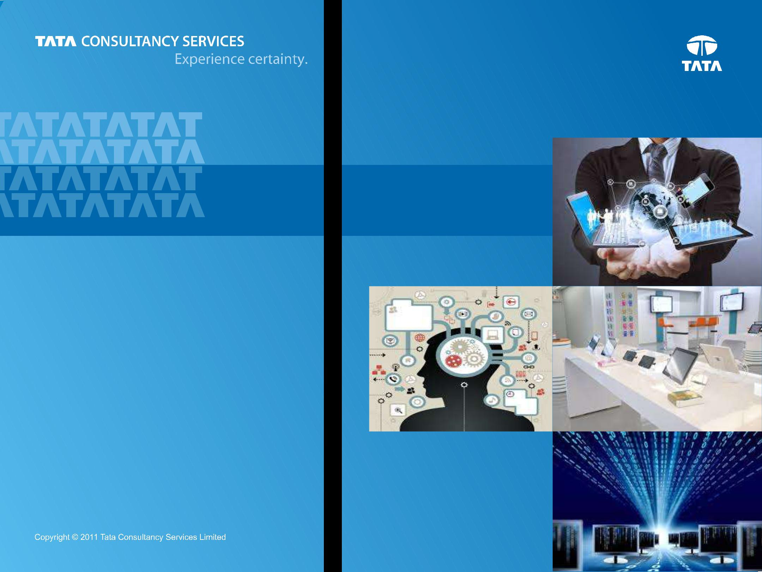

Customer’s View of Bank

Prepared : October, 2014

1

Content


Introduction

Customer

Digital Banking

Channel Transformation

Effects on Retail LoBs

2


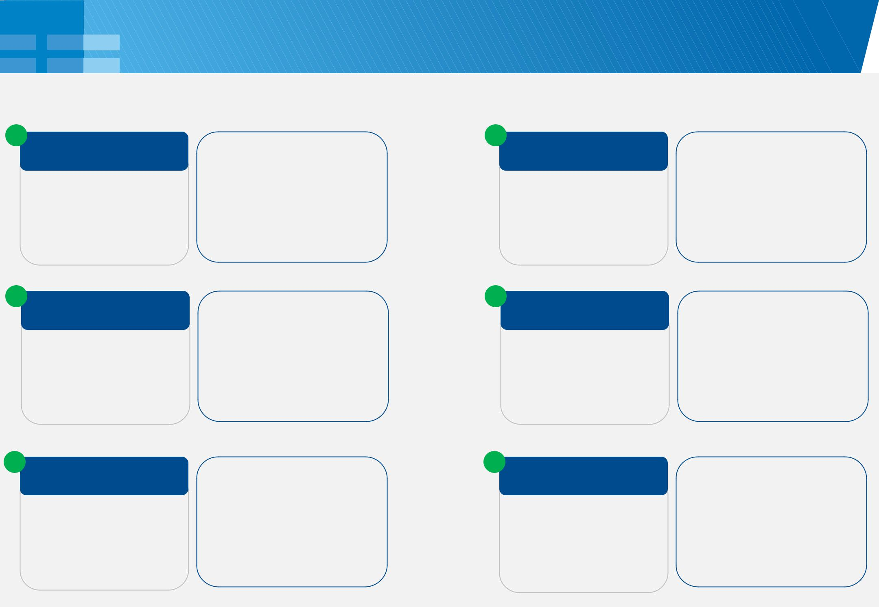
Channel Transformation : Branch

Featuring in Branch of the Future Foundations for Branch of the Future

1
Customer Identification

- SSO across Channels

- Biometrics (Voice, Retina, Fingerprint), Beaming Technologies (BLE / RFID)

- Voice Biometrics piloted as extension of Speech Recognition for Authentication and Fraud management

- Biometrics at ATM

4
Cross Channel

- Context Transference

- Unified Service Broker

- Customer profile based CEP

• Appointment Set up for

branch interaction

• Social integration

(Facebook, Twitter) for

banker/teller desktop

2
Customer Touch Points

Teller, Banker Desktop,

Surface, Kiosk, Tablet,

Video Banking, Smart

TV, Digital Signage

3
Customer Intimacy

- Queue Management

- Transaction Pre Staging

• Agent Desktop with Relationship panorama
3 • Surface for Loyalty
2
redemption in London Olympics ₂
• Second Screen

3

2

- Smart Concierge

- Origination on Tablet

- Credit Card Bill Pay at ATM / Kiosk using bar code
3 |  | 2
 |  | 5
 |  | Business Services
 | 3 | • | Front Office
 | 3 |  | Automation
 |  | • | Paper less
 |  | • | Assisted to Self

1

6
Utility Services

- Branch in a Box

- Branch Analytics

- Enterprise Content Management on Cloud

• Paperless On Boarding

• Digital Signature & mRDC

• Push2Mobile for offline

read thru and

confirmation

• Peripheral Decoupling

• Cloud Based document

management

• Client Cross Channel

interaction dashboard

3

Channel Transformation : Voice

Platform Components = Multi Channel Capability + Integrated CRM + Analytics Platform … all converging with the Digital channels to provide a seamless customer experience.


From Customer Lens

Interact Any How

Seamlessly traversal (multi modal) across channels, Enhanced Verification & Fraud prevention


Reach out Any Way

Video Chat & Click to Call enabling Personalized Services, Context Transference, Integrated Authentication

Feel the Interaction

Visual VR ensuring Enriched Customer Experience, Reduced time (pre set favorite menus) before agent picks

Bank Enablement

Talking to Us

Enhanced customer interaction, Security thru Voice Navigation & Biometrics (Voice Assistant)

Listening to you

Social Media Integration Via Click to Call / Chat / Video, Unified Communications, Universal Queue Management

Understanding You

Advanced analytics (word spotting, emotion, talk pattern, interaction history, customer 360)

4

Channel Transformation : Call Centre

Paradigms of change broadly includes information quality (timely, relevant) and

“multi channel in tandem” experiences


Agent and User Mobile | Card Member availability | Churn & Next Best Action
Agent and User Mobile | Card Member availability | Proactive flagging of possible
Context transference like | Agent awareness of card | Proactive flagging of possible
Context transference like | Agent awareness of card | churn, retention offers,
pushing links to encourage | member’s presence online | churn, retention offers,
pushing links to encourage | member’s presence online | adaptive model is to analyze
self servicing | while being on call | adaptive model is to analyze
self servicing | while being on call | customer’s action on the offer


Facebook Chat & Call
Integration | Agent Learning | Second Screen
Real time response to social | Agent Learning | Online channel session
Real time response to social | Collaboration platform using | Online channel session
posts (Pega Social Intercept), | Collaboration platform using | experience ‘continued’ into
posts (Pega Social Intercept), | IM, receive real time feedback | experience ‘continued’ into
route customer to right agent | IM, receive real time feedback | mobile via QR code from
route customer to right agent | on servicing patterns | mobile via QR code from
post call / chat based on | on servicing patterns | online
preference


Sentiment / Keyword | Payment Calendar | Home Page
Sentiment / Keyword | Payment Calendar | Personalization
From Social conversation, | Set up recurring payments | Personalization
From Social conversation, | Set up recurring payments | Screen content and pop ups
services records for | with actionable alerts for | Screen content and pop ups
services records for | with actionable alerts for | based on customer context
improvement opportunities | triggering / stopping payment | based on customer context
improvement opportunities | triggering / stopping payment | for pin point cross sell

5
Channel Transformation : Mobile

Possibilities (End Customer)

- Mobile OAO with ID scanning

- Mobile Photo Bill Pay and Balance Transfer

- Contactless Payment - NFC / Sticker

- Pay thru e-mail / phone number / FB contact

- Mobile Payments for SME (cash, card, check, BPay, Spilt Billing, Tipping)

Convenience

- Balance without logging in

- Branch Concierge

- Beacon Based Proximity solutions

- Integration with Scheme checkouts

- Card-less cash withdrawal

- Control the card (lock, block, limit)

- Search / Locate

Possibilities (Bank)

- Bank App Store, 3rd Party Developer Platform

- Commercial Bank analytics (cash flow, sales, customers)

- POS traffic

- Mobile Collect as a closed loop settlement system

Peace of Mind

- Multi factor authentication via OTP

- Facial Verification

- Device Awareness

- Behavioral Awareness

- Track / Remote Wipe

- Key pre set and system generated Alerts / Reminders

6

Banking “on” Social Media in general and …

Fundamentals |  |  |  | Program Imperatives
Visual |  | Mobility | Genotypes / | Social Media Planning | FINRA, FFIEC
Resonance |  | Mobility | Profiling | Framework (with CMO) | (with CRO)
Channel Differentiation & |  |  |  | (strategy, experience, organizational
 |  |  | Usage of | collaboration & change, processes, | Command Centre
 | Relevance |  | Usage of | metrics (KPIs) | Command Centre
 |  |  | Gamification | metrics (KPIs) | Command Centre
 |  |  | Gamification | metrics (KPIs) | (monitor, manage,
 |  |  | Gamification | information, technology) | (monitor, manage,
 |  |  | Techniques | information, technology) | promote, communicate)
Search |  | Responsive-
Optimization |  | ness | Constantly refined messaging and increased engagement thru ‘Halo’ marketing


Brand + Customer Engagement + New Revenue


Credit Risk | Social P2P |  | Banking with | Customer
Analysis based | Social P2P | Social Insurance | Social Principles | engagement
Analysis based | Lending & | Social Insurance | Social Principles | engagement
on Social Media | Lending & | & Investing | (product, | (#my360
on Social Media | Marketplace | & Investing | (product, | (#my360
Profile | Marketplace |  | pricing) | independence)
 | Gamification to | Social | Theme based
 | promote | Social | messaging
 | promote | Community | messaging
 | different | Community | (social, military
 | different | based (TDHelp) | (social, military
 | behaviors | based (TDHelp) | sports)

7
.. and Facebook & Twitter in particular
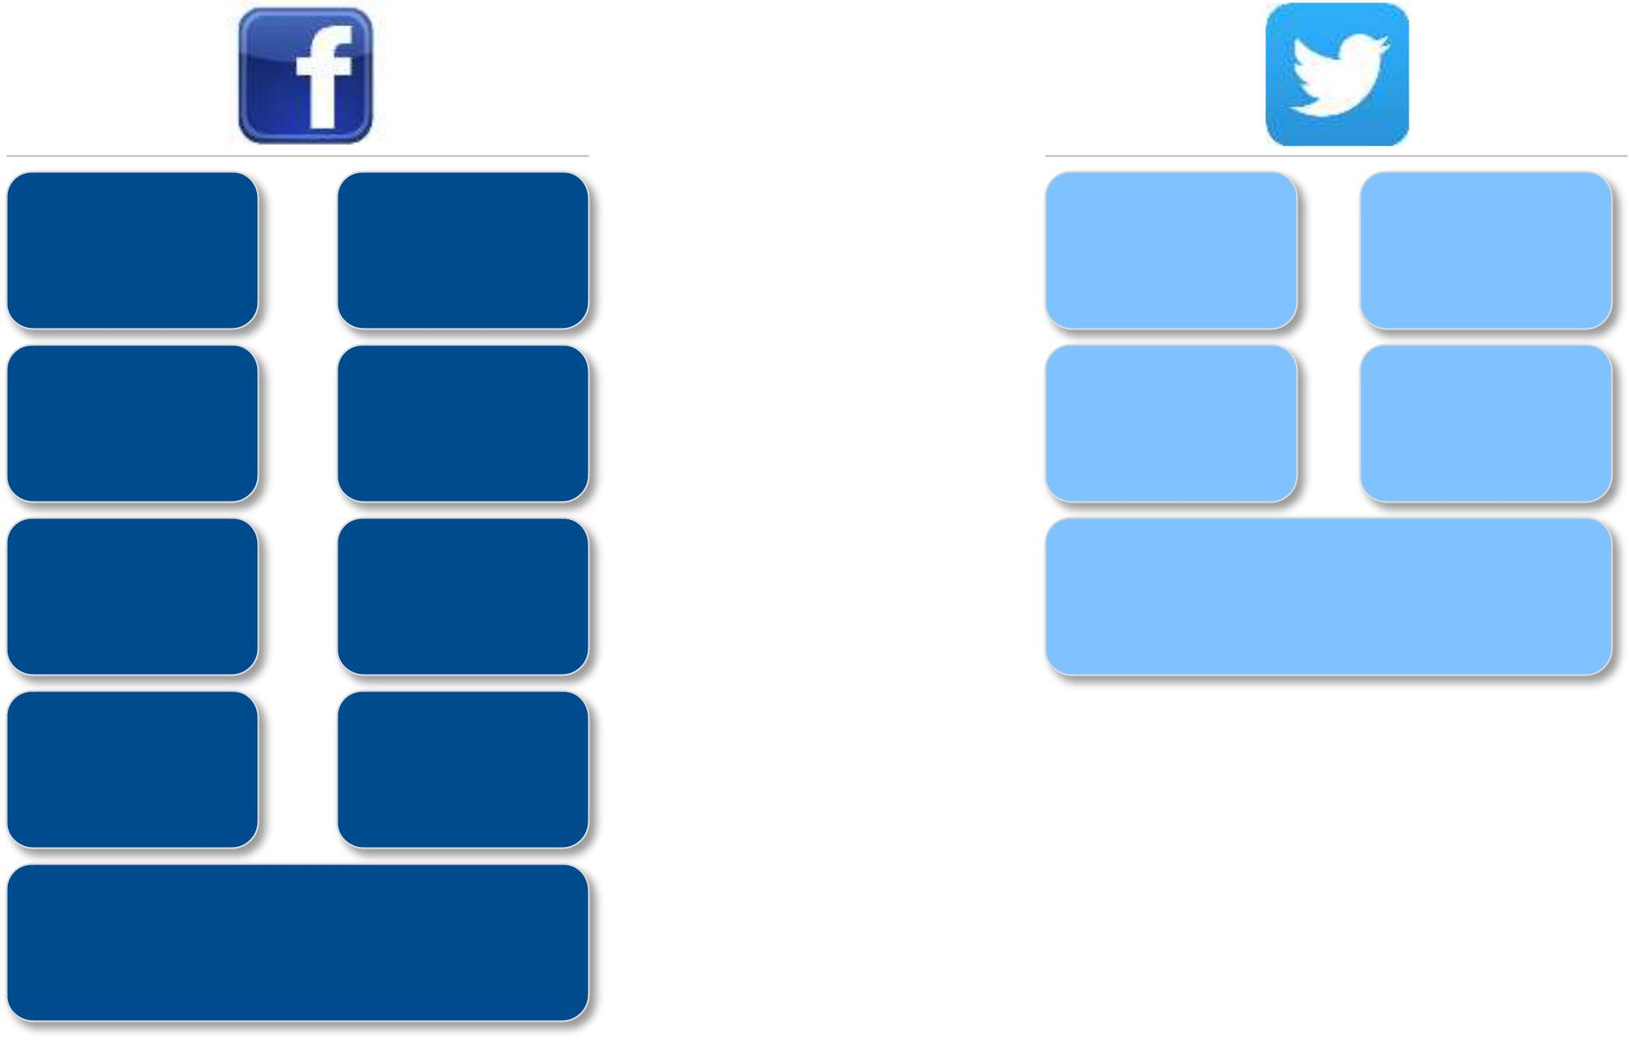

Integration | Dashboard:
with Bank | Account,
Online | Cards, Bills
Donations to | Payments:
supported | Payments:
supported | Card, P2P
charity | Card, P2P
Alerts and | Rewards:
Alerts and | Accrue,
Notifications | Accrue,
Notifications | Redeem, Gift
FAQs, Click | Share
FAQs, Click | (Event Planner,
to Chat / Call | (Event Planner,
to Chat / Call | Offers)

Personalized Cards

(from FB photos, prefixed designs based on prior likes preferences)

Customer
Social
Care
Intercept
“Reach out”

Card linked
Tweet
Offer
to Pay
Enrollment

Merchant Offers

(Posted into a marketplace that can be tagged by clients)



Financial Advisor profile in

Welcome kit

8

Social Media usage in BRIC

Emerging economies represent a new frontier in this space with a faster growth (including Gen Y) customer base, mobile penetration & savviness .. Hence, more innovation


India : ICICI, Yes Bank

- Complete online banking app on Facebook; no need to leave social media

- Communication hub with all informational services and few operations

- Engaging activities related to products/services, money usage in daily life

- Customer education thru Inspirational quotes, quizzes, comics, iWish

- Customer Care Service in multiple languages


Russia : Sberbank
- Communication and Financial literacy on Facebook, Twitter, YouTube, Flickr and VK

- VK (Vkontakte) with Gamified app with points based ranking for credit card usage, “run together” for Sochi Olympics

- “Classmates” portal with info on products and inputs from community

- Special edition angry birds themed Mastercard promoted on Facebook
Brazil : Itau, Bradesco
- Communication hub with all informational services and few operations

- Strong linkages with Brazil culture (football, carnival)

- Negative sentiments (posts, viral video) due to missing services & sponsoring national football team

- Split Twitter channels - PR and customer care

China : Bank of China, Merchants Bank
- Mostly services, corporate activity and customer care with links to other handles on credit cards, tourism

- Engaging micro blogs on weekend movie recommendations, ‘ask what common mistakes folks make online’, calamity, charity
- Embedded in bank online prominently

- Weibo versus Weixin

- Banks using WeChat for marketing activities

9

Social Lending

Enabled by introduction online lending marketplaces ; without Capital requirements and Counterparty risks

Operating Model

- Match potential lenders with borrowers

- Risk mitigation by identity & credit checks, spreading funds, peer pressure on lagging payees

- Contract enforcement, payment & collections

Revenue Model

- Annual fee on the amount lent & borrowed

- % age of earned interest from Lenders

- Early withdrawal fee if lenders decide to withdraw money before loan maturity date

- Loan bids thru auctions

How will traditional banks counter ?

Making it Easy

- Loan approvals to be simpler and quicker

- Tailored pricing including personal circumstances into Risk and Interest Rates

- Value added services for borrowers like digital PFM for financial planning (rather than compete on interest rates)

Making it interesting

- mBank offers freelance workers a special account package with 2 associated accounts - private & business; income in both accounts can be used to assess credit worthiness

- La Caixa in Spain had “You Choose, You Decide” campaign for customers to have a say in reinvestment of a portion of the profits

- New Zealand's Heartland Bank invests in P2P lending platform HarMoney

Note:

- Zopa has default rate of 0.81 % compared to US Bank average 2.4 % delinquency

- Lending Club (3.5 B by Feb 2014), Prosper (869 M) and Zopa (754 M)

- Funding Circle, RateSetter & Zopa set up P2P Finance Association (P2PFA) in Aug 2011 ; loans made can be included in the tax-advantaged individual savings account (IRA)

- Possible accelerators : Amazon, Google, PayPal
10

Social Investing

Personal investing reimagined bringing the wisdom of experts via the following modes :

(1) Exchange of Ideas, (2) Follow of Trades and (3) Automatically ‘copy’ trades

Sample Operating Models

eToro: leaderboard for users to track performance (# of copiers, profitable weeks, gain %) and copy top traders

Wikifolio: Investors publish investing strategy and create an investable portfolio

Trade King: Share broker verified trades

Covestor: replicates lead investors’ trades in clients’ accounts

How will traditional banks counter ?

Increasing transparency: established firms need to give their clients more information about their own historical performances, with visualization tools for data such as balances over time

Provide Social Platform: for investors to share ideas with like-minded investors; Broker-dealers offering this include Cortal Consors, E-Trade, and TradeKing

Note:

- MIT Media Lab shows that individual investors who trade using eToro’s CopyTrader, earn 4% more on average than they would on their own

- Covestor’s $13.5 million and Wikifolio’s $220 million in assets are a tiny fraction of the wealth managed by established firms.

11

Summarizing: Digital Channel Strategy Imperatives

Adopt multi channel strategy providing consistent customer experience across all channels individually and contextual support in more than one channel simultaneously

Empower customers for more DIY with assistive, intuitive and engaging tools to view, explore, understand, plan, track and transact


Use ‘on-the-go’ devices to provide Anytime Anywhere Any how Banking and Adopt a Mobile First Approach

Engage customers on Social Media and leverage digital breadcrumbs therein for deeper insight, relationship with the brand

Harness the data inside and outside the bank to derive 360 degree Customer & Enterprise intelligence via comprehensive Analytics

Create a Single Customer View with contact history across all touch points

And of course, Simplify and Transform legacy to enable all above possibilities via a robust and scalable architecture

12
Next Chapter : 5

Introduction

Customer

Digital Banking

Channel Transformation

Effects on Retail LoBs

13



THANK YOU

Prepared : October, 2014

14

